# Technical Design Document: Programming_Exercise_7

# Name: Christian Innes
# Date: November 1st, 2026
# Program Description:
Gets student test information and puts it into a csv file
##Function:
Takes info and write it in a file and then reads the file
##Parameters:
Grades.csv: File Name
R: Reads
A: Append
##Variables:
first_name: Stores the First Name
Last_name: Stores the Last Name
Exam1: Stores the 1 exam grade
Exam2: Stores the 2 exam grade
Exam3: Stores the 3 exam grade
Num_students: Stores number of students
##Logic:
Take information
Returns information in a csv file
Make the csv file tabular formatted
##Return:
Returns with a CSV.File filed with information
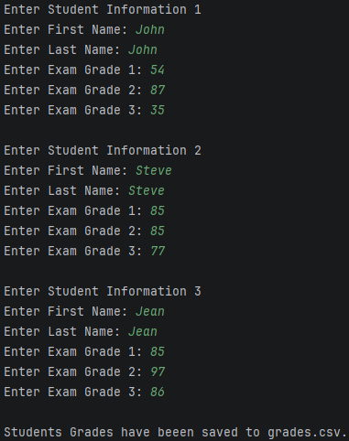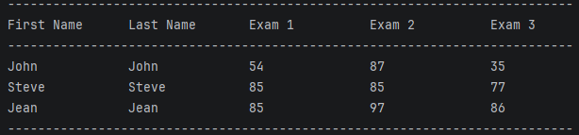
https://github.com/monky6676/COP2373

